Häkkinen et al. 2013. Land use as an aspect of sustainable building.
ELECTRONIC SUPPLEMENTARY MATERIAL 1
Description and background information of life cycle assessment made for Finnish average block of buildings in the article
Results and short description of a life cycle assessment (LCA) for Finnish average block of buildings are presented in the section Life-cycle perspective on land use of buildings of this article. Background information on modelling selections and life cycle data sources is given in this electronic supplementary material (ESM) 1. Please cite the main Häkkinen et al. 2013 article in case you need to refer to this material.
Goal and scope
The goal of this LCA was to find out what is the significance of land use that happens because of the land occupation of buildings and related construction assets compared to the land use caused by the rest of a building value chain. The LCA study focused on Finnish block of flats with 50 year lifespan based on average data published in Ruuska et al. (2013). Functional unit was one year of use of a building.

Life cycle inventory
The average values from Ruuska et al. (2013) were used as the basis for input material and land use needs in this study (Table ESM1.1). The life cycle inventory (LCI) data sources on land occupation and transformation needs for respective material inputs is presented in Table ESM1.2. More detailed modelling was needed for inclusion of land occupation and transformation needs connected to boreal forest biomass and heat and power supply. This modelling is presented in the following sections.
Forest land-use
Forest biomass input is needed in both wood-based construction materials and in bioenergy production. An assumption was made in this study that wood-based construction materials are made from hardwood (birch) and bioenergy from softwood (Norway spruce) sourced from sustainability managed forests in Scandinavia. Data on forest harvests and total managed forestland in Southern-Finland was applied based on Finnish Statistical Yearbook of Forestry (Metla 2011):
- Annual harvest in the area: 45,753,000 m³ in 2010
- 11 million ha of productive forestland was under managed forestry
- Thus average annual yield of forest biomass in Southern Finland is 4.2 m³/ha_{forest, intensive}.
With densities of 390 kg,dry/m³ and 600 kg,dry/m³ for Norway spruce and birch, respectively (Jyske et al. 2008), land occupation flows were calculated as 6.2 m²a/kg,dry and 4.0 m²a/kg,dry for Norway spruce and birch, respectively. These results were used as land occupation inventory flows for forest biomass inputs in the model. High land occupation need for forest biomass can be explained by two factors: Relatively low annual increment of forest biomass in high-latitude Boreal region, and low share of harvests compared to annual increment in Finland in 2000s (Köhl et al. 2011; Metla 2011). No land transformation was allocated to forest biomass sourced from sustainably managed Scandinavian boreal forests.

Table ESM1. 1. Material inputs and land area needs applied in this study based on Ruuska et al. (2013). Over 98% of the input materials (on mass basis) were included while the materials in grey were excluded from this study.
<Functional unit> | 50 | years | 1 | year
Block of houses FI avg | 1 | pcs | 0,02 | pcs
INPUTS
<Energy>
electric power | 7700 | MWh | 154 | MWh
heat energy | 37400 | GJ | 748 | GJ
<Materials/Products>
concrete | 3397000 | kg | 67940 | kg
gravel | 421000 | kg | 8420 | kg
crushed rocks | 176000 | kg | 3520 | kg
screed (concrete) | 101000 | kg | 2020 | kg
light gravel | 37000 | kg | 740 | kg
steel | 37000 | kg | 740 | kg
gypsum plate/plasterboard | 29000 | kg | 580 | kg
particle board | 24000 | kg | 480 | kg
wood | 22000 | kg | 440 | kg
parging | 20000 | kg | 400 | kg
window glass | 19000 | kg | 380 | kg
tiles | 17000 | kg | 340 | kg
sand lime brick | 16000 | kg | 320 | kg
aluminium | 14000 | kg | 280 | kg
parquet | 14000 | kg | 280 | kg
mineral wool | 13000 | kg | 260 | kg
EPS | 7000 | kg | 140 | kg
plastic mat | 7000 | kg | 140 | kg
bitumen | 6000 | kg | 120 | kg
paint | 4000 | kg | 80 | kg
PVC-plastic | 3000 | kg | 60 | kg
copper | 2000 | kg | 40 | kg
damp-proof | 2000 | kg | 40 | kg
porcelain | 2000 | kg | 40 | kg
PP-plastic | 2000 | kg | 40 | kg
PE-plastic | 1000 | kg | 20 | kg
rock | 1000 | kg | 20 | kg
stucco | 1000 | kg | 20 | kg
<Land use>
Occupation, industrial area, built up | 20000 | m2a | 400 | m2a
Occupation, industrial area, vegetation | 225000 | m2a | 4500 | m2a

Table ESM1. 2. LCI data sources on land occupation and transformation flows.
 | LCI data source | Additional information
 |  | ecoinvent process name etc.
<Energy>
electric power | Calculated (1) | See section ’modelling of energy’
heat energy | Calculated (1) | See section ’modelling of energy’
<Materials/Products>
concrete | Ecoinvent 2.2 | concrete, normal, at plant, LCI
gravel | Ecoinvent 2.2 | gravel, unspecified, at mine, LCI
crushed rocks | Ecoinvent 2.2 | gravel, unspecified, at mine, LCI
screed (concrete) | Ecoinvent 2.2 | concrete, normal, at plant, LCI
light gravel | Ecoinvent 2.2 | gravel, unspecified, at mine, LCI
steel | Ecoinvent 2.2 | reinforcing steel, at plant, LCI
gypsum plate/plasterboard | Ecoinvent 2.2 | gypsum plaster board, at plant, LCI
particle board | Ecoinvent 2.2 | particle board, outdoor use, at plant, LCI
wood | Calculated (2) | See section ’forest land-use’
parging | Ecoinvent 2.2 | concrete, normal, at plant, LCI
window glass | Ecoinvent 2.2 | flat glass, uncoated, at plant, LCI
sand lime brick | Ecoinvent 2.2 | brick, at plant, LCI
aluminium | Ecoinvent 2.2 | aluminium, production mix, at plant, LCI
parquet | Calculated (2) | See section ’forest land-use’
mineral wool | Ecoinvent 2.2 | rock wool, packed, at plant, LCI (50%); and
 |  | glass wool mat, at plant, LCI (50%)

Modelling of energy
Land-use impacts related to heat and power consumption in the use phase of the building were modelled based on Finnish five year (2004-2008) average power and heat supply mixes (IEA Energy statistics 2010), Figure ESM1.1. Because the overall result of the building value chain proved to be sensitive to the assumptions related to energy production fuel mix, an alternative scenario analysis was carried out with OECD Europe’s power supply mix and natural gas as a source of heat energy. Respective fuel needs per 1 GJ of heat and 1 MWh power in Finland and OECD Europe are present in Table ESM1.3. These fuel inputs and hydro power generation rates were used in modelling the land occupation and transformation flows connected to heat and power consumption in the use phase of the building. Results on land-use occupation for energy production pathways is presented in Figure ESM1.2. Land occupation in heating with 100% natural gas is negleglible compared with other fuel mixes, 0.047 m²a/GJ (Ecoinvent 2010), thus excluded from Figure ESM1.2.

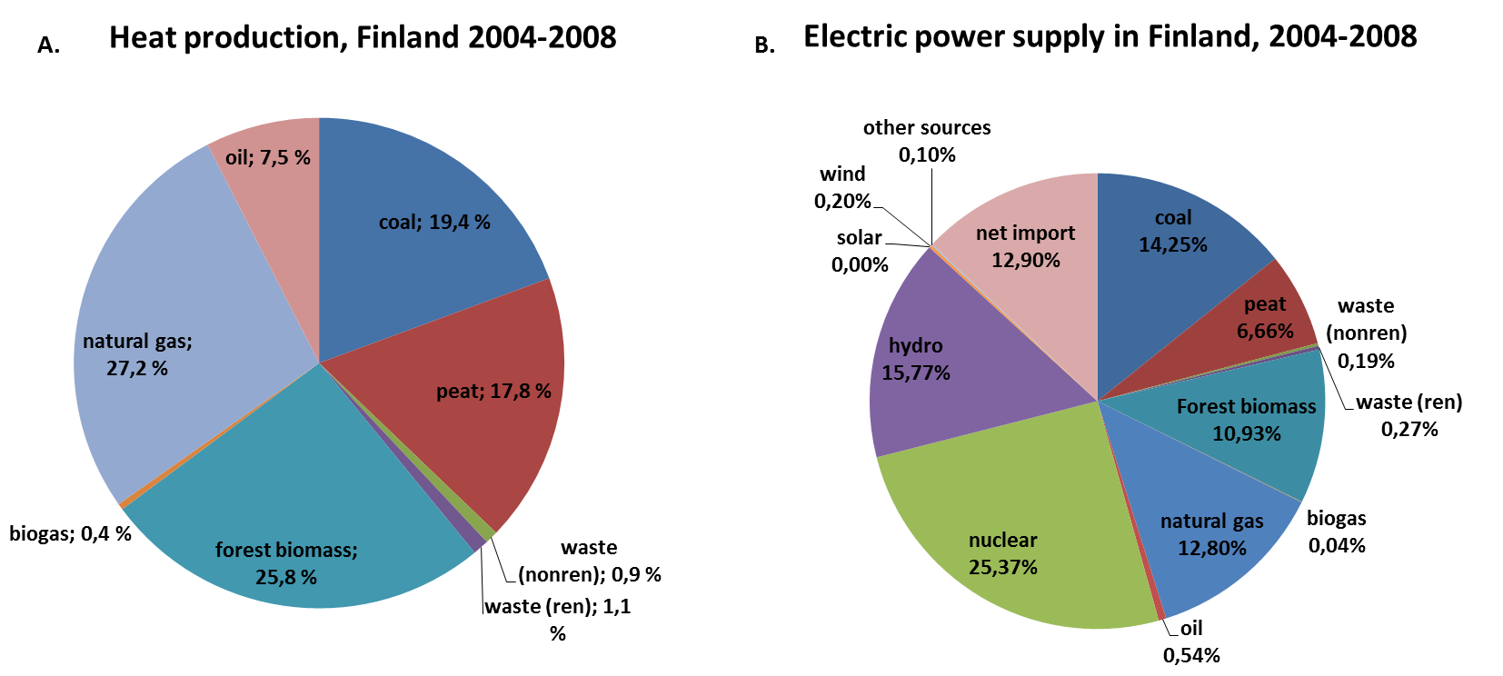
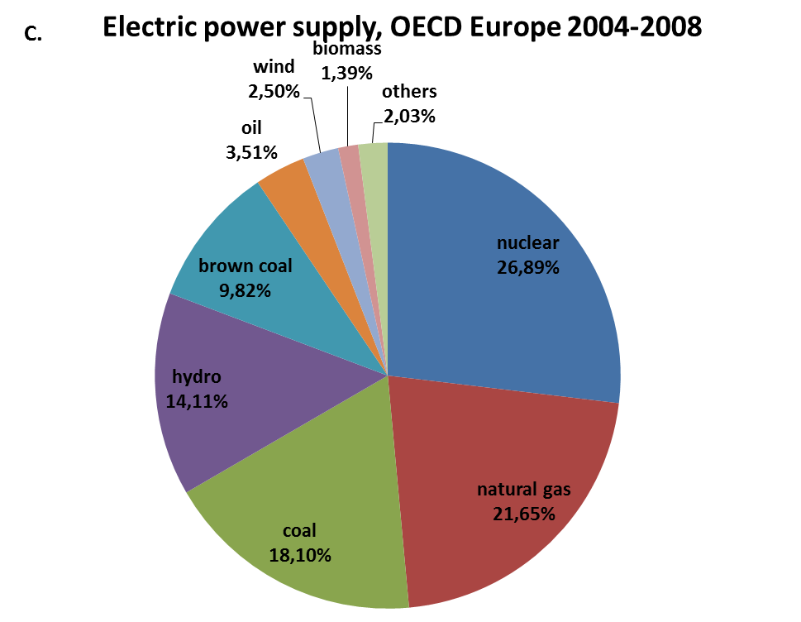
Figure ESM1.1. Average fuel supply mix in 2004-2008 in (a) heat production in Finland (b) power supply in Finland and (c) power supply in OECD Europe (IEA Statistics 2010). Note: Net import in Finnish power supply is mainly sourced from Russia (48% natural gas, 19% hard coal, 16% hydro, 16% nuclear and 2% the rest).
Peat excavation
A significant share of power and heat is produced from peat in Finnish energy mixes (Figure ESM1.1). Land-use inventory data on production of peat was thus estimated based on Finnish average data. Extraction of peat has varied in between 20-29 TWh,fuel in 2004-2010 and a total of 63 000 ha of mires are occupied for peat excavation (Leinonen et al. 2010). An average estimate of 25 TWh was applied in this study, resulting in annual peat yield of 144 MJ,fuel (HHV)/ m²a. With an heating value of 21.6 MJ/kg,peat (dry matter basis) the land occupation need for peat fuel is 0.15 m²a/kg,peat (dry matter basis).
As one peat excavation site can be assumed to be used for 10-20 years, 5-10% of occupied area is abandoned every year and same amount of new mires occupied for peat production. It was assumed that ca. 7% (0.010 m²/kg,dry peat) of the area is transformed from forestry-drained peatlands (forest,extensive) to peat excavation site and simultaneously same amount of sites are abandoned. Common practice in Finland is to reforest the abandoned peat-excavation sites into managed forests (forest, intensive). Thus a net land transformation of 0.010 m² forest from extensive to intensive was connected to 1 kg,peat (dry matter).
Table ESM1. 3. Modelled fuel inputs and other energy sources with land-use implications in Finnish heat supply (FI Heat) Finnish power supply (FI Power) and OECD Europe power supply (EUR Power).
 | FI Heat | FI Power | EUR Power |  | Data source for land use
 | 1 GJ | 1 MWh | 1 MWh |  | Ecoinvent process name or calculated
<Fuel inputs (dry matter)>
Energy wood (Norway spruce) | 18 | 26 | 3,3 | kg | Calculated (1)
Peat | 12 | 14 | 0,6 | kg | Calculated (2)
Hard coal | 9,5 | 40 | 52 | kg | Hard coal, at mine, LCI
Natural gas | 6,4 | 12 | 20 | kg | Natural gas, at production onshore, RU
Heavy fuel oil | 2,1 | 0,7 | 5,1 | kg | Crude oil, at production onshore, RU, LCI
Brown coal | - | - | 127 | kg | Lignite, at mine, LCI
Uranium enriched 3% | - | 0,001 | 0,001 | kg | U enriched 3.0%, in fuel element
 |  |  |  |  | for LWR, at nuclear fuel fabrication plant
<Other energy sources with land use>
Hydropower | - | 0,164 | 0,146 | MWh | Electricity, at wind power plant, UPR
Imported power | - | 0,134 | - | MWh | Calculated (3)
Calculated (1): See section ’forest land-use’.
Calculated (2): See section ‘Peat excavation’.
Calculated (3): Land use from Russian power production (2008 data) is modelled with the same method as reported here for Finland and OECD Europe.

Figure ESM1.2. Land occupation flows connected to different energy production pathways applied for use phase of building in this study. Results are presented relative to the respective energy-unit (MWh or GJ).
Life cycle impact assessment
For convenience, all the characterization factors used in the land use life cycle impact assessment (LCIA) phase of the study are in Appendix ESM1.1 (in end of this document).
References
Ecoinvent. 2010. Ecoinvent life cycle inventory database v2.2. Swiss Centre for Life Cycle Inventories
IEA International Energy Agency. 2010. Energy Statistics on OECD Countries for years 2004-2008. IEA Statistics.
Leinonen, A., 2010. Production and Use of Peat. Summary of studies (In Finnish. Turpeen tuotanto ja käyttö. Yhteenveto selvityksistä). Espoo 2010. VTT Research Notes 2550. 104 p.
Jyske, T., Mäkinen, H., Saranpää, P., 2008. Wood density within Norway spruce stems. Silva Fennica 42(3): 439–455.
Metla: Finnish Forest Research Institute. 2011. Finnish Statistical Yearbook of Forestry 2011. Finnish Forest Research Insitute, Vantaa. 470 p.
Ruuska, A., Häkkinen, T., Vares, S., Huovila, A. 2013. Rakennusmateriaalien merkitys rakentamisen ympäristövaikutusten kentässä. (The role of construction materials in environmental impacts of construction activities). VTT Notes, Espoo.
VTT Technical Research Centre of Finland. 2012. Life-cycle inventory database for transports, production of heat and power, chemicals and production processes of chemical wood industry.
APPENDIX ESM1.1. Description of characterization factors used in LCIA phase.
Land use type nomenclature is partly modified from the original source data (listed below 1-5). Disclaimer: The authors of this article (and this supplementary material) do not take any responsibility for the further use of the set of characterization factors presented below or its possible and unintended divergence from the original publications.

 |  | Ecological footprint (gm2a) | HANPP (kg C) | Soil Organic Carbon, SOC (kgC yr) | Biotic production potential, BPP (kgC yr) | Biodiversity damage potential, BDP (PDF)
Original sources (see reference list below the table): |  | 1) | 2) | 3) | 4) | 5)
Occupation, arable |  | 2,51 | 0,2992 | 9,7 | 20,54 | 0,6
Occupation, arable, integrated |  | 2,51 | 0,2992 | 9,7 | 20,54 | 0,6
Occupation, arable, irrigated |  | 2,51 | 0,2992 | 9,7 | 20,54 | 0,6
Occupation, arable, non_irrigated |  | 2,51 | 0,2992 | 9,7 | 20,54 | 0,6
Occupation, arable, non_irrigated, diverse_intensive |  | 2,51 | 0,2992 | 9,7 | 20,54 | 0,6
Occupation, arable, non_irrigated, fallow |  | 2,51 | 0,2992 | 9,7 | 20,54 | 0,6
Occupation, arable, non_irrigated, monotone_intensive |  | 2,51 | 0,2992 | 9,7 | 20,54 | 0,6
Occupation, arable, organic |  | 2,51 | 0,2992 | 9,7 | 20,54 | 0,6
Occupation, construction site |  | 2,51 | 0,38 | 15 | 58,21 | 0,44
Occupation, dump site |  | 2,51 | 0,36 | 15 | 58,21 | 0,44
Occupation, dump site, benthos |  | 2,51 | 0,36 | 0 | 0 | 0
Occupation, forest |  | 1,26 | 0,14875 | 0 | 0 | 0,18
Occupation, forest, extensive |  | 1,26 | 0,14875 | 2 | 0 | 0,18
Occupation, forest, intensive |  | 1,26 | 0,14875 | 2 | 0 | 0,18
Occupation, forest, intensive, clear_cutting |  | 1,26 | 0,14875 | 2 | 0 | 0,18
Occupation, forest, intensive, normal |  | 1,26 | 0,14875 | 2 | 0 | 0,18
Occupation, forest, intensive, short_cycle |  | 1,26 | 0,14875 | 2 | 0 | 0,18
Occupation, heterogeneous, agricultural |  | 2,51 | 0,2992 | 6,9 | 20,54 | 0,6
Occupation, industrial area |  | 2,51 | 0,38 | 14,8 | 58,21 | 0,44
Occupation, industrial area, benthos |  | 2,51 | 0,38 | 0 | 0 | 0,44
Occupation, industrial area, built up |  | 2,51 | 0,38 | 15 | 58,21 | 0,44
Occupation, industrial area, vegetation |  | 2,51 | 0,26 | 11 | 58,21 | 0,44
Occupation, meadow |  | 0,46 | 0,0976 | 5 | 0 | 0,33
Occupation, mineral extraction site |  | 2,51 | 0,36 | 15 | 58,21 | 0,44
Occupation, pasture |  | 0,46 | 0,0976 | 5 | 0 | 0,33
Occupation, pasture and meadow |  | 0,46 | 0,0976 | 5 | 0 | 0,33
Occupation, pasture and meadow, extensive |  | 0,46 | 0,0976 | 5 | 0 | 0,33
Occupation, pasture and meadow, intensive |  | 0,46 | 0,0976 | 5 | 0 | 0,33
Occupation, pasture and meadow, organic |  | 0,46 | 0,0976 | 5 | 0 | 0,33
Occupation, permanent crop |  | 2,51 | 0,0976 | 7 | 0 | 0,42
Occupation, permanent crop, fruit |  | 2,51 | 0,0976 | 4 | 0 | 0,42
Occupation, permanent crop, fruit, extensive |  | 2,51 | 0,0976 | 4 | 0 | 0,42
Occupation, permanent crop, fruit, intensive |  | 2,51 | 0,0976 | 4 | 0 | 0,42
Occupation, permanent crop, vine |  | 2,51 | 0,0976 | 4 | 0 | 0,42
Occupation, permanent crop, vine, extensive |  | 2,51 | 0,0976 | 4 | 0 | 0,42
Occupation, permanent crop, vine, intensive |  | 2,51 | 0,0976 | 4 | 0 | 0,42
Occupation, sea and ocean |  | 0,37 | 0 | 0 | 0 | 0
Occupation, shrub land, sclerophyllous |  | 0,46 | 0 | 0,83 | 80,02 | 0,18
Occupation, traffic area |  | 2,51 | 0,36 | 15 | 58,21 | 0,44
Occupation, traffic area, rail embankment |  | 2,51 | 0,36 | 12 | 58,21 | 0,44
Occupation, traffic area, rail network |  | 2,51 | 0,36 | 15 | 58,21 | 0,44
Occupation, traffic area, road embankment |  | 2,51 | 0,36 | 12 | 58,21 | 0,44
Occupation, traffic area, road network |  | 2,51 | 0,36 | 15 | 58,21 | 0,44
Occupation, tropical rain forest |  | 1,26 | 0 | 0 | 0 | 0
Occupation, unknown |  | 2,51 | 0 | 9,7 | 0 | 0
Occupation, urban, continuously built |  | 2,51 | 0,38 | 14,6 | 58,21 | 0,44
Occupation, urban, discontinuously built |  | 2,51 | 0,34 | 14,6 | 58,21 | 0,44
Occupation, urban, green areas |  | 2,51 | 0,26 | 0 | 58,21 | 0,44
Occupation, water bodies, artificial |  | 1 | 0 | 0 | 0 | 0
Occupation, water courses, artificial |  | 1 | 0 | 0 | 0 | 0
Transformation, from arable |  | 0 | 0 | -485 | -205,4 | -27,216
Transformation, from arable, non_irrigated |  | 0 | 0 | -485 | -205,4 | -27,216
Transformation, from arable, non_irrigated, diverse_intensive |  | 0 | 0 | -485 | -205,4 | -27,216
Transformation, from arable, non_irrigated, fallow |  | 0 | 0 | -485 | -205,4 | -27,216
Transformation, from arable, non_irrigated, monotone_intensive |  | 0 | 0 | -485 | -205,4 | -27,216
Transformation, from arable, non-irrigated |  | 0 | 0 | -485 | -205,4 | -27,216
Transformation, from arable, non-irrigated, diverse-intensive |  | 0 | 0 | -485 | -205,4 | -27,216
Transformation, from arable, non-irrigated, fallow |  | 0 | 0 | -485 | -205,4 | -27,216
Transformation, from arable, non-irrigated, monotone-intensive |  | 0 | 0 | -485 | -205,4 | -27,216
Transformation, from dump site |  | 0 | 0 | -3750 | -2464,5 | -14,636
Transformation, from dump site, benthos |  | 0 | 0 | 0 | 0 | 0
Transformation, from dump site, inert material landfill |  | 0 | 0 | -3750 | -2464,5 | -14,636
Transformation, from dump site, residual material landfill |  | 0 | 0 | -3750 | -2464,5 | -14,636
Transformation, from dump site, sanitary landfill |  | 0 | 0 | -3750 | -2464,5 | -14,636
Transformation, from dump site, slag compartment |  | 0 | 0 | -6000 | -2464,5 | -14,636
Transformation, from forest |  | 0 | 0 | -20 | 0 | 0
Transformation, from forest, extensive |  | 0 | 0 | -20 | 0 | 0
Transformation, from forest, intensive |  | 0 | 0 | -20 | 0 | -2,4494
Transformation, from forest, intensive, clear_cutting |  | 0 | 0 | -20 | 0 | -2,4494
Transformation, from forest, intensive, clear-cutting |  | 0 | 0 | -20 | 0 | -2,4494
Transformation, from forest, intensive, normal |  | 0 | 0 | -20 | 0 | -2,4494
Transformation, from forest, intensive, short_cycle |  | 0 | 0 | -20 | 0 | -2,4494
Transformation, from forest, intensive, short-cycle |  | 0 | 0 | -20 | 0 | -2,4494
Transformation, from heterogeneous, agricultural |  | 0 | 0 | -245 | -205,4 | -3,024
Transformation, from industrial area |  | 0 | 0 | -7400 | -2464,5 | -14,636
Transformation, from industrial area, benthos |  | 0 | 0 | 0 | 0 | 0
Transformation, from industrial area, built up |  | 0 | 0 | -7500 | -2464,5 | -14,636
Transformation, from industrial area, vegetation |  | 0 | 0 | -1100 | -2464,5 | -14,636
Transformation, from mineral extraction site |  | 0 | 0 | -7500 | -2464,5 | -14,636
Transformation, from pasture and meadow |  | 0 | 0 | -125 | 0 | -8,2328
Transformation, from pasture and meadow, extensive |  | 0 | 0 | -125 | 0 | -8,2328
Transformation, from pasture and meadow, intensive |  | 0 | 0 | -125 | 0 | -8,2328
Transformation, from permanent crop |  | 0 | 0 | -350 | -205,4 | -13,336
Transformation, from permanent crop, fruit |  | 0 | 0 | -100 | -205,4 | -13,336
Transformation, from permanent crop, fruit, extensive |  | 0 | 0 | -100 | -205,4 | -13,336
Transformation, from permanent crop, fruit, intensive |  | 0 | 0 | -100 | -205,4 | -13,336
Transformation, from permanent crop, vine |  | 0 | 0 | 0 | -205,4 | -13,336
Transformation, from permanent crop, vine, extensive |  | 0 | 0 | 0 | -205,4 | -13,336
Transformation, from permanent crop, vine, intensive |  | 0 | 0 | 0 | -205,4 | -13,336
Transformation, from sea and ocean |  | 0 | 0 | 0 | 0 | 0
Transformation, from shrub land, sclerophyllous |  | 0 | 0 | -21 | -80,02 | -2,4494
Transformation, from traffic area, rail embankment |  | 0 | 0 | -3750 | -2464,5 | -14,636
Transformation, from traffic area, rail network |  | 0 | 0 | -3750 | -2464,5 | -14,636
Transformation, from traffic area, road embankment |  | 0 | 0 | -3750 | -2464,5 | -14,636
Transformation, from traffic area, road network |  | 0 | 0 | -5250 | -2464,5 | -14,636
Transformation, from tropical rain forest |  | 0 | 0 | 0 | 0 | 0
Transformation, from unknown |  | 0 | 0 | -1721 | 0 | 0
Transformation, from urban, continuously built |  | 0 | 0 | -7300 | -2464,5 | -14,636
Transformation, from urban, discontinuously built |  | 0 | 0 | -7300 | -2464,5 | -14,636
Transformation, from water bodies, artificial |  | 0 | 0 | 0 | 0 | 0
Transformation, from water courses, artificial |  | 0 | 0 | 0 | 0 | 0
Transformation, to arable |  | 0 | 0 | 485 | 205,4 | 27,2157
Transformation, to arable, non_irrigated |  | 0 | 0 | 485 | 205,4 | 27,2157
Transformation, to arable, non_irrigated, diverse_intensive |  | 0 | 0 | 485 | 205,4 | 27,2157
Transformation, to arable, non_irrigated, fallow |  | 0 | 0 | 485 | 205,4 | 27,2157
Transformation, to arable, non_irrigated, monotone_intensive |  | 0 | 0 | 485 | 205,4 | 27,2157
Transformation, to arable, non-irrigated |  | 0 | 0 | 485 | 205,4 | 27,2157
Transformation, to arable, non-irrigated, diverse-intensive |  | 0 | 0 | 485 | 205,4 | 27,2157
Transformation, to arable, non-irrigated, fallow |  | 0 | 0 | 485 | 205,4 | 27,2157
Transformation, to arable, non-irrigated, monotone-intensive |  | 0 | 0 | 485 | 205,4 | 27,2157
Transformation, to arable, organic |  | 0 | 0 | 485 | 205,4 | 27,2157
Transformation, to dump site |  | 0 | 0 | 3750 | 2464,52 | 14,636
Transformation, to dump site, benthos |  | 0 | 0 | 0 | 0 | 0
Transformation, to dump site, inert material landfill |  | 0 | 0 | 3750 | 2464,52 | 14,636
Transformation, to dump site, residual material landfill |  | 0 | 0 | 3750 | 2464,52 | 14,636
Transformation, to dump site, sanitary landfill |  | 0 | 0 | 3750 | 2464,52 | 14,636
Transformation, to dump site, slag compartment |  | 0 | 0 | 6000 | 2464,52 | 14,636
Transformation, to forest |  | 0 | 0 | 20 | 0 | 0
Transformation, to forest, extensive |  | 0 | 0 | 20 | 0 | 0
Transformation, to forest, intensive |  | 0 | 0 | 20 | 0 | 2,44941
Transformation, to forest, intensive, clear_cutting |  | 0 | 0 | 20 | 0 | 2,44941
Transformation, to forest, intensive, clear-cutting |  | 0 | 0 | 20 | 0 | 2,44941
Transformation, to forest, intensive, normal |  | 0 | 0 | 20 | 0 | 2,44941
Transformation, to forest, intensive, short_cycle |  | 0 | 0 | 20 | 0 | 2,44941
Transformation, to forest, intensive, short-cycle |  | 0 | 0 | 20 | 0 | 2,44941
Transformation, to heterogeneous, agricultural |  | 0 | 0 | 245 | 205,4 | 3,02397
Transformation, to industrial area |  | 0 | 0 | 7400 | 2464,52 | 14,636
Transformation, to industrial area, benthos |  | 0 | 0 | 0 | 0 | 0
Transformation, to industrial area, built up |  | 0 | 0 | 7500 | 2464,52 | 14,636
Transformation, to industrial area, vegetation |  | 0 | 0 | 1100 | 2464,52 | 14,636
Transformation, to mineral extraction site |  | 0 | 0 | 7500 | 2464,52 | 14,636
Transformation, to pasture and meadow |  | 0 | 0 | 125 | 0 | 8,23275
Transformation, to pasture and meadow, extensive |  | 0 | 0 | 125 | 0 | 8,23275
Transformation, to pasture and meadow, intensive |  | 0 | 0 | 125 | 0 | 8,23275
Transformation, to pasture and meadow, organic |  | 0 | 0 | 125 | 0 | 8,23275
Transformation, to permanent crop |  | 0 | 0 | 350 | 0 | 13,3357
Transformation, to permanent crop, fruit |  | 0 | 0 | 100 | 0 | 13,3357
Transformation, to permanent crop, fruit, extensive |  | 0 | 0 | 100 | 0 | 13,3357
Transformation, to permanent crop, fruit, intensive |  | 0 | 0 | 100 | 0 | 13,3357
Transformation, to permanent crop, vine |  | 0 | 0 | 0 | 0 | 13,3357
Transformation, to permanent crop, vine, extensive |  | 0 | 0 | 0 | 0 | 13,3357
Transformation, to permanent crop, vine, intensive |  | 0 | 0 | 0 | 0 | 13,3357
Transformation, to sea and ocean |  | 0 | 0 | 0 | 0 | 0
Transformation, to shrub land, sclerophyllous |  | 0 | 0 | 21 | 80,02 | 2,44941
Transformation, to traffic area, rail embankment |  | 0 | 0 | 3750 | 2464,52 | 14,636
Transformation, to traffic area, rail network |  | 0 | 0 | 3750 | 2464,52 | 14,636
Transformation, to traffic area, road embankment |  | 0 | 0 | 3750 | 2464,52 | 14,636
Transformation, to traffic area, road network |  | 0 | 0 | 5250 | 2464,52 | 14,636
Transformation, to tropical rain forest |  | 0 | 0 | 0 | 0 | 0
Transformation, to unknown |  | 0 | 0 | 1953 | 0 | 0
Transformation, to urban, continuously built |  | 0 | 0 | 7300 | 2464,52 | 14,636
Transformation, to urban, discontinuously built |  | 0 | 0 | 7300 | 2464,52 | 14,636
Transformation, to water bodies, artificial |  | 0 | 0 | 0 | 0 | 0
Transformation, to water courses, artificial |  | 0 | 0 | 0 | 0 | 0
 | List of source data references
1) | Ewing, B., Reed, A., Galli, J., Kitzes, J., Wackernagel, M., 2010. Calculation methodology for the National Footprint Accounts, 2010 Edition. Oakland: Global Footprint Network.
2) | Haberl, H., Erb, K.H., Krausmann, F., Gaube, V., Bondeau, A., Plutzar, C., 2007. Quantifying and mapping the human appropriation of net primary production in Earth's terrestrial ecosystems. PNAS 104: 12942-47.
3) | Milà i Canals L, Muñoz I, McLaren S, Brandão M. 2007b. LCA methodology and modelling considerations for vegetable production and consumption. CES Working Paper 02/07. ISSN: 1464-8083
4) | Brandão, M. & Milà i Canals, L. 2012. Global characterisation factors to assess land use impacts on biotic production. Int J Life Cycle Assess (in press) DOI 10.1007/s11367-012-0381-3
5) | de Baan, L., Alkemade, R., Koellner, T. 2012. Land use impacts on biodiversity in LCA: a global approach. Int J Life Cycle Assess (in press). DOI 10.1007/s11367-012-0412-0

