Characterization of Citrus Peel Maturation to Reduce Postharvest Storage Problems in Florida

Shamel M. Alam-Eldein^{1,2}, R. L. Rouseff¹ and L. G. Albrigo¹

¹Citrus Research and Education Center, Institute of Food and Agricultural Sciences
University of Florida, Lake Alfred, Florida, 33850, USA
²Department of Horticulture, Faculty of Agriculture, Tanta University, Tanta, 31527, Egypt

Additional index words: Citrus × paradisi, Citrus sinensis, maturity, flavedo, albedo, harvest date, sugars, glycosidases, abscisic acid, peel volatiles, bloom date, principal component, stepwise regression

Abstract
This is a study to create an index to measure the rate of peel maturation in citrus as it relates to postharvest handling and keeping quality. Currently, citrus is harvested based on internal quality. Peel changes have not been related to best harvest time. Several physical and chemical parameters were measured for harvest dates to determine if peel maturation and senescence can be monitored by some combination of factors in order to minimize fruit disorders during storage resulting from immature or senescent peel or unusual stress that the peel may have been subjected to. Water stress and growth regulators were used to make difference in biochemical changes and change the rate of peel maturity. Changes in levels of sugars, glycosidases, abscisic acid and volatile components during maturation coincided with changes in peel color, percent fruit drop and with fruit characteristics during storage (weight loss, decay and chilling injury) may be useful for establishing harvest date guidelines to avoid harvesting too early or too late, so that less postharvest injuries occur while the fruit still has acceptable internal quality. Days from bloom date, detachment force and peel reducing sugars were the best indicators for a peel senescence index. It is hard to say whether peel maturity and pulp maturity changes occur simultaneously or differently during the season; however, changes in TSS: acid ratio were sometimes significantly related to changes in weight loss, decay and chilling injury of the peel, which may give indication about the coincidence of pulp and peel maturity.

A unique aspect of citrus is the probable separate maturity aspects of peel and internal edible portions. External peel characterization may or may not follow internal juice changes, which are used as grade standards. It is imperative to make sure that citrus fruits are palatable and meet internal maturity standards when harvested. It is also important to characterize peel maturation level to determine integrity and susceptibility to damages during pre-packing and handling treatments, as well as susceptibility to decay and physiological disorders during storage, transportation and marketing.
As a non-climacteric fruit, citrus do not "ripen" in the general sense of the word as it is applied to climacteric fruits; instead, they mature to good eating quality and, as such, do not exhibit a well defined period of rapid conversion of stored starch to sugars or other soluble products (Soule and Grierson, 1986). Instead, compositional changes occur gradually, and hence the internal portion of the fruit, the endocarp, becomes edible. This process has been termed “maturation.” The inedible portion of the fruit, the peel, probably “matures” also. Although many compositional changes have been reported in the peel (Huff, 1984; Mitcham and McDonald, 1993; Murti, 1988; Purvis and Grierson, 1982), maturity in this tissue often refers to its susceptibility to injury (Burns and Baldwin, 1994). The points at which the citrus peel passes from immature to mature state, as well as from maturity to senescence have been difficult to define, in part, because of the gradual and slower nature of physiological changes in citrus fruit. The physiological changes (e.g. sugars, enzyme activity, phytohormones, volatile components, etc.) that occur during peel maturation could be used to define peel maturity more accurately (Burns and Baldwin, 1994). Some factors (water stress and growth regulators) were studied to induce differences in maturity (advance or delay, respectively), so that they could be used to add information to this study and indicate the stage of peel development; however they are not the natural way to cause maturation changes and their role is minor to harvest dates as a main way to get peel changes and storability differences. Water stress induces the process of cell senescence (Sharon-Asa et al., 2003) through specific changes in cell ultrastructure, metabolism and gene expression (Munne-Bosch and Alegre, 2004). Fruit growth is considered as one of the most sensitive indicators of water stress in citrus (Cohen and Goell, 1984; Hilgeman, 1977). Depending on cultivar and timing, growth regulators can also be used to extend the harvest season by delaying rind aging (Davies and Albrigo, 1994). Gibberellic acid (GA₃) and 2,4-D are used primarily as a preharvest treatment to delay certain aspects of rind senescence of navel orange and seedless grapefruit (Coggins, 1981).
The hypotheses of this study was that as harvest dates advance, citrus fruit peel will change from immature to mature to senescent, and peel physical, metabolic, or enzymatic changes will reflect these changes. Water stress will advance citrus peel aging, but growth regulators (GA3 and 2,4-D) will delay it. The objectives that post storage variables (weight loss, decay and chilling injury) are indicators of peel problems and that the goal was to find a combination of peel physical and chemical measurements that as they changed indicated the maturing and senescing process of the peel, and to study some factors or conditions that might affect citrus peel maturity, which in turn may affect fruit quality and storability of citrus fruits. These factors can be used to increase differences in maturity (i.e. advance or delay) and to see if any physical or chemical measurements show corresponding changes in amount or rate, which might indicate that they could be used to indicate the stage of peel development (immature, mature, senescent).

Materials and Methods

Field and storage experiments
Experiments were carried out in two mature citrus blocks at Citrus Research and Education Center (CREC), one of ‘Marsh’ grapefruit in the 2004/2005 and 2005/2006 seasons and the second of ‘Valencia’ orange in the 2005/2006 season. Water stress (WS) were applied from November 15th through February 1st of the 2005/2006 season, and and plant growth regulators (PGR), 20ppm GA3 & 10ppm 2,4-D, were sprayed at the stage of fully enlarged green fruit on December 5th. Grapefruit was harvested monthly (September – May) in the 2004/2005 season and every two months (September – May) in the 2005/2006 season. ‘Valencia’ fruit were harvested every two months (January – July) in the 2005/2006 season. At each harvest date; one box (30 fruit) was stored at 40ºF (4.5°C) and 90% RH and another box was stored at 70ºF (21°C) and 90% RH for 12 weeks.

Physical measurements
Peel color was measured on three different spots on the equatorial part of the fruit using a Konica Minolta chromometer (measuring head model CR-300 and data processor model DP-301, Konica Minolta Sensing America Inc., Ramsey, NJ, USA). Color was analyzed using the Hunter L, a, b scale (Hunter associates Laboratory, Inc. Reston, Virginia, USA), and the color index was calculated using the following formula; (1000 * a) / (L * b) (Jimenez-Cuesta et al., 1981).
Peel puncture resistance was measured using a Wagner fruit tester (FT Series, Wagner Instruments, CT, USA) on three different spots on the equatorial part of the fruit and averaged. Readings were recorded in Kg when oil glands were disrupted and oil released.
Fruit detachment force (FDF) was measured using the same device used for puncture resistance; fruit stem (peduncle) was clipped to 5cm in length, inserted into the gauge, and the stem pulled parallel to the fruit axis. Readings were taken in Kg when detachment of the fruit from the stem occurred.
Weight loss was measured for 10 fruit per replicate by weighing the fruit at harvest and every two weeks during storage until the end of the storage period. The difference as a percentage from the original weight (at harvest) was calculated.
Fruit decay and chilling injury (CI) were measured visually every two weeks until the end of the storage period. The number of infected/injured fruit were counted and presented as the percentage from the original number of fruit/box (30). Fruit that had a minimum of three different chilling-injured spots were considered chilling-injured and removed from the box. Fruits that had any kind of decay were removed from the box.

Chemical measurements
At every harvest date, juice TSS: acid ratio was determined in the juice processing laboratory at CREC’s packinghouse using FMC equipment for juice extraction and analysis. Ten fruit out of each replicate were chosen for chemical analyses and the flavedo layer was removed using an apple peeler (Back to Basics Products, Inc., Draper, UT, USA). Then the albedo layer was removed with a regular stainless steel knife. Flavedo and albedo tissues were immediately frozen in liquid nitrogen (Valero et al., 1998) and stored at -80ºC (Forma -86ºC ULT Freezer, Forma Scientific Inc., Marietta, OH, USA) until used for chemical analyses.
For each sample, 100mg of flavedo was mixed with 2ml of 80% ethanol in a centrifuge tube and left at room temperature for 30 minutes. The same process was used for the albedo tissue. After 30 minutes, the mixture was centrifuged again for 5 minutes, then 50 µL of the supernatant were taken for sucrose analysis and 20 µL of the supernatant were taken for reducing sugars analysis. Sucrose was estimated by the method of Handel (1968) and reducing sugars were estimated by the method of Nelson (1944) and Somogy (1952).
Glycosidases extractions were made according to the method of Burns and Baldwin (1994) and protein was estimated by the method of Bradford (1976) using bovine serum albumin (BSA). The methodology of Sigma-Aldrich (St. Louis, MO, USA) was used to measure β-galactosidase activity according to Distler and Jourdian (1973) with a minor change of extending the incubation time from 10 to 15 minutes, and α-mannosidase activity was measured according to Lee (1972) and Li (1967) with a minor change of extending the incubation time from 5 to 10 minutes.
Abscisic acid (ABA) extraction was done according to the method of Miller et al.(1987) for IAA extraction and the method of Yuan et al. (2001) for IAA and ABA extraction. Quantitative determination of ABA was done using Phytodetek ABA Enzyme Immunoassay Test Kit, competitive enzyme-linked immunosorbent assay (ELISA), from Agdia Incorporated, Elkhart, IN, USA (PDK 09347/0096). TBS buffer and ABA standard sticks (RS 09347) were obtained from Agdia Inc. ELISA is an effective method to measure ABA in crude extracts without excessive cleanup procedures (Norman et al., 1990).
At every harvest date, ten fruit out of each replication were chosen for oil extraction and analyses. The flavedo layer was removed using an apple peeler (Back To Basics Products, Inc., Draper, UT, USA) and then oils were expressed from the flavedo using a garlic squeezer. The extracted solutions were collected in 2 ml eppendorf tubes and stored in a regular freezer until analyzed. The contents of the tubes were collected in a glass vial and mixed well. Sample vials were placed in a water bath at 40ºF for 30 minutes to concentrate the volatile components in the headspace above the solution. After cleaning at 240ºC for 5 minutes, a solid phase microextraction fiber (SPME, 50/30um DVB/Carboxen/PDMS StableFlex, manual holder, gray, Supelco Inc., Bellefonte, PA, USA) (Arthur and Pawliszyn, 1990; Marsili, 2000) was inserted into the vial in the headspace above the solution for 20 minutes exposure time for extraction of volatiles which were injected into the Gas chromatograph-Mass (GC-MS, Clarus 500, PerkinElmer, Waltham, Massachusetts, USA) for analysis (Hites, 1997). The SPME fiber was removed from the GC-MS after 5 minutes. Every sample was run twice.

Statistics
Principle component analyses (PCA) was performed using Unscrambler X, version 10.1 multivariate data analysis software (CAMO Software, Inc., Woodbridge, NJ, USA) for all physical and chemical variables with the control and all treatments (water stress, growth regulators and the combined treatment) to see if there were trends in the data and if there were any differences among data for early, mid- and late season harvests. Multiple stepwise regression (MSR) analysis was run, using SAS 9.2 (SAS Institute Inc., 2008), for each one of the postharvest characteristics; weight loss, decay and chilling injury at 12 weeks as dependant variables versus other physicals and chemical parameters measured at harvest. R² and p-values were evaluated for significant relationship between variables. Both MSR and PCA were run for combined years.

Results and Discussion
‘Marsh’ Grapefruit at 40ºF (4.5ºC)
To obtain a broader picture about grapefruit peel maturation, selected physical characteristics that represent postharvest problems, such as, weight loss, decay and chilling injury were analyzed with other physical and chemical variables using PCA so that trends and covariance could be discerned. Scores of each data point (harvest date × treatment) as well as variables that were used to create data trends for the combined seasons, are represented in Figure 1. The first two components of this PCA explained 41% of the total variance, with the first and second PC accounting for 24% and 17%, respectively. The low explanation of data variance (41%) resulted from the low degree of clustering and may also be due to the overlap between samples from early season and mid-season, as well as between mid-season and late season samples (Fig. 1); however, away from overlap areas, the observed proximity of some given samples can explain their load for specific variables, for instance, there were three separated clusters consisting of a cluster for early season fruit (4SC, 4OC, 4NC and 5SC) that includes fruit with the highest flavedo β-galactosidase, compared to the second cluster of mid-season samples (5FC and 5MrC) that have the highest α-pinene, myrcene, linalool and flavedo ABA. The third cluster is for fruit harvested in late season (6MyC, 6MyWG, 6JlC, 6JlW, 6JlG and 6JlWG) that can be differentiated using variables in the dimension, such as Juice TSS/acid ratio, flavedo sucrose, flavedo reducing sugars, albedo reducing sugars, nootkatone and days from bloom date. Also, this third cluster has the lowest score in PC-1 and PC-2 in the dimension of FDF and flavedo β-galactosidase, since they are located on the opposite side of this cluster (Fig. 1). Among the three groups, harvest dates were not separated with respect to the rest of physical or chemical variables. This is probably because the other factors had very little variation in values throughout the harvest season. Late harvested fruit showed the highest % weight loss and lowest detachment force, which were related negatively to each other since they are located in two different quadrant of the PCA plot as shown in Figure 1. Table 1 showed that grapefruit % weight loss at 40ºF was significantly related to 4 variables measured at harvest and accounted for 52 % of the variance in weight loss values. % chilling injury and % decay are post storage variable, and they can’t be useful as a harvest predictor of handling ability. The remaining two variables; juice TSS: acid ratio and peel color are accounted 48% of the variance in weight loss values. TSS: acid accounted for most of the multiple linear regression equation accounting for 34% of the weight loss variation. Color accounted for the other 14 % of variation. % decay was significantly related to 2 variables accounted for 34% of the variance. Flavedo sucrose measured at harvest and accounted for 26% of the variance, but chilling injury is not useful as a harvest predictor. % chilling injury was significantly related to 2 variables accounted for 41% of the total variance. Decay can’t be used as a harvest predictor and peel color measured at harvest and accounted for 7% of the variance.
The later the harvest date was from bloom date, the more susceptible the fruit to decay. Fruit harvested early season (September – October period) showed fairly high % weight loss that decreased gradually until (December - January period) then start to increase again toward the end of growing season. Chilling injury was high early season (40.4%), and low mid-season (26.8%), then increased again late season (32.6%) (Alam-Eldein, 2011). Increase in weight loss and decay with the progress of the harvest season, as well as the susceptibility of early and late season harvested fruit to chilling injury were previously reported (Coggins et al., 1969a; Ritenour et al., 2003). The % weight loss and % chilling injury were significantly correlated with color, and the % decay was significantly correlated with flavedo sucrose (Table 1). These relationships are interesting because they shows more susceptibility to chilling injuries as flavedo sucrose increased (slope = 0.21, reciprocal relationship between decay and chilling injury) which preceded color change (slope = 2.37) (Table 1). Significant increases in color index (from -9.47 & -10.85 in September to -5.92 & -3.33 in November) were associated with significant increases in chilling injury (from 12.41 & 43.33 in September to 41.85 & 65.78 in November) during the first and second seasons, respectively (Alam-Eldein, 2011). These results agree with a previous finding by Kawada (1980) who found that immature grapefruits were more resistant to CI than those harvested after color break. Also, Lafuente et al. (1997) that chlorophyll increases chilling injury resistance for early harvested fruit. It was previously reported that chilling has related to oxidative stress (Harayadi and Punkin, 1991; Wise and Taylor, 1987) and that chlorophyll been demonstrated to protect plants against oxidative damage (Larson, 1988). These data show that to some extent under subtropical condition, like Florida, peel color index may be used as a quick and easy tool to determine the level of peel maturity, however it would not be a very accurate tool because color change is temperature dependent (Young and Erickson, 1961), but at least as previously reported it coincides with the beginning of peel maturity (Erickson, 1960).
Fruit becomes less firm with maturation, and senescing peel has an albedo layer with small cells of low cytoplasmic content, low metabolic activity, larger intercellular spaces and weakened cell wall, which break easily (Coggins, 1969b). Figure 1 showed that firmness located in the overlap area between mid- and late season harvested fruit, but it can not be related statistically to these samples because it had low variance values in either PC-1 or PC-2. Moreover, the MSR did not show any significant relationship between firmness and any postharvest variables (Table 1). Figure 1 showed that late season samples treated with growth regulators and the combination of water stress and growth regulators (6JlG and 6JlWG) had the highest TSS: acid ratio compared to fruit treated with water stress (6JlW) and the control (6JlC) while they had the highest nootkatone and % weigh loss compared to the first group. Alam-Eldein (2011) confirm these results and showed no significant differences among all treatments and the control with respect to TSS: acid ratio, nootkatone and % weight loss. A role of water stress and/or growth regulators in causing differences in maturity rate (i.e. advance or delay) by adjusting the biochemical changes of the peel was not indicated from these results. Using the interval between bloom date and harvest date to determine the proper time of fruit harvesting is an option, but it did not show any significant results with any of postharvest variables (Table 1). To reduce the postharvest problems, harvest season may start sometime after November (early December; where least weight loss, decay and chilling injury found(Alam-Eldein, 2011)) and the cut-off point of harvested ‘Marsh’ grapefruit to be stored at 40ºF should not be later than March, or possibly early April (since weight loss and chilling injury are more related to May and July harvested fruit that may represent the period of senescent peel, Fig. 1).

‘Marsh’ Grapefruit at 70ºF (21ºC)
Since no chilling injury occurs at 70ºF, only weight loss and decay were detected postharvest problems and are discussed in relation to other physical and chemical variables. Figure 2 shows that the first two components of the PCA plot also accounted for 41% of the total variance, as at 40ºF, with the first and second PCs accounting for 25% and 16%, respectively. Fruit harvested early (4SC, 4OC, 4NC and 5SC) were the highest in flavedo β-galactosidase and FDF, and these were the only two variables that differentiated this early harvested group. Flavedo β-galactosidase was significantly related to % weight loss of early season harvested fruit, and this relationship was positive (slope = 11.97) (Table 1). Previous findings reported that the high initial β-galactosidase activity was consistent with the first sampling date, September. Cell wall β-galactosidase has been associated with actively growing tissue, where high levels of this enzyme activity have been correlated with cell wall loosening mechanisms responsible for growth (Labrador and Nicolas, 1984). Table 1 showed that grapefruit % weight loss at 70ºF was significantly related to 5 variables measured at harvest and accounted for 69 % of the variance in weight loss values, and Flavedo β-galactosidase was the most contributing variable to the regression equation because it has the highest slope. Flavedo sucrose and reducing sugars accounted for most of the multiple linear regression equation accounting for 61 % of the weight loss variation, respectively. Flavedo β-galactosidase and α-mannosidase, and TSS: acid values accounted for the other 8 % of variation. Flavedo sucrose and flavedo reducing sugars were both related significantly to % weight loss, but they were located in the overlap area between mid- and late season samples (Fig. 2), so they can not be used to differentiate specific harvest group. The difference between fruit from all treatments harvested mid-season in March (6MrW, 6MrG and 6MrWG) and control was not significant, and same thing for fruit harvested late season in May (6MyW, 6MyG and 6MyWG) (Alam-Eldein, 2011). Although flavedo α-mannosidase was significantly related to % weight loss (Table 1), mid-season harvested fruit could not be compared with respect to this variable in PCA because it is projected close to the center of the PCA plot (Fig. 2). Late season fruit harvested in July can be differentiated by TSS: acid ratio, days from bloom date, and nootkatone (Fig. 2), but the only significant relationships were between postharvest variables (weight loss and decay) and TSS: acid ratio (Table 1). The PCA plot (Fig. 2) also showed that the variables firmness and % decay were related to mid- and late season fruit, however they both were insignificantly related to each other, but these results are in agreement with previous reports; as fruits become older, susceptibility to postharvest diseases increases, because peel becomes less firm and hence less force is required to puncture the peel (Coggins et al., 1969a).
Decay was negatively correlated with FDF since they are in two opposite quadrants of the PCA plot (Fig. 2), and FDF has negative slope (-5.86; Table 1). Grapefruit % decay at 70ºF was significantly related to 2 variables measured at harvest and accounted for 38 % of the variance in decay values (Table 1). Juice TSS: acid ratio accounted for most of the multiple linear regression equation accounting for 29 % of the decay variation. FDF values accounted for the other 9 % of variation. As the growing season progressed and the internal fruit maturity increased, FDF decreased gradually and susceptibility to decay increased (Juste et al., 1988; Ladaniya, 2008). The significant results between FDF and decay may make FDF a good candidate to determine the level of peel maturity. Use would still be limited because of the narrow range of detachment forces found (Alam-Eldein, 2011). The limit of minimum detachment needs more investigation, and FDF is affected by several factors, such as tree moisture level. Less force was required to remove oranges following rains and early in the morning when the fruit was in a turgid condition (Coppock, 1961). Detachment force and percentage plugged of ‘Marsh’ grapefruit decreased with greater detachment angles (Coppock et al., 1969). Also, FDF of ‘Navel’ orange increased with increasing fruit size and larger stem/peduncle diameter (Hield et al., 1967; Kender and Hartmond, 1999). At early maturity, citrus fruit are firmly attached to the stem, and FDF is extremely variable within the tree, generally being higher in the top and exterior parts of the canopy where fruit are more exposed to the sun and develop stronger stems (Kender and Hartmond, 1999). In general, wounding or mechanical injuries of the peel reduce FDF due to triggering of internal ethylene which initiates formation of the abscission zone. The closer the location of the wound to the calyx abscission zone, the larger the reduction in FDF (Kostenyuk and Burns, 2004). Fruit detachment force is positively correlated with the ratio of endogenous IAA to ABA or endogenous IAA, but negatively to endogenous ABA in the fruit abscission zone (Rasmussen, 1973; Yuan et al., 2001). This relationship between endogenous hormones may give some indication about using water stress and/or growth regulators to adjust the internal level of ABA, but still needs more research on using ABA as an indicator of peel maturity, especially since this data showed no significant difference between WS or GR treatment and control during mid- and late season (Alam-Eldein, 2011). % weight loss and % decay for fruit harvested and stored at 40oF and 70ºF have almost the same trend during the season with higher rate at 70ºF, and they both increase toward the end of the season (Alam-Eldein, 2011). Figure 1 showed that at 40ºF fruit showed more decay with mid-season harvest in March until late season in May, but high % weight loss was more related to May and July harvest, whereas at 70ºF (Fig. 2), high % decay was more related to mid season fruit harvested in March until late season in July, but weight loss was more related to early season samples harvested in September until mid-season fruit harvested in January. So, it is suggested that the harvest window of fruit to be stored at 70ºF should be shorter than that for fruit stored at 40ºF. The beginning of harvest season may be sometime by late December and the cut-off point should not be later than late March, since the biochemical changes and the deterioration rate of the peel is faster at 70ºF than 40ºF.

‘Valencia’ Orange at 40ºF (4.5ºC)
In the storage experiment at 40ºF ‘Valencia’ oranges during the 2005/2006 season, the harvest date data were better related than for grapefruit in terms of good clustering and minimum overlap among the three harvest periods: early, mid- and late season (Fig. 3). This may be due to fewer variables and less harvest dates compared to grapefruit. The first two components of PCA explained 57% of variance with PC-1 and PC-2 explaining 35% and 22 % of the total variance, respectively. The correlation between % decay and % chilling injury was significantly positive (Table 2). Firmness and reducing sugars content of both flavedo and albedo differentiated early season samples harvested in January from all other harvest dates, and both variables were positively related to decay since they all located in the same direction from the center (Fig. 3). Table 2 showed that ‘Valencia’ orange % weight loss at 40ºF was significantly related to 2 variables measured at harvest and accounted for 63 % of the variance in weight loss values. TSS: acid accounted for most of the multiple linear regression equation accounting for 54% of the weight loss variation. Albedo reducing sugars accounted for the other 9 % of variation. % decay was significantly related to 3 variables accounted for 54% of the variance. Linalool measured at harvest and accounted for 34% of the variance, and firmness accounted for 8% of the variance. Chilling injury accounted for 12%, but it is not useful as a harvest predictor. % chilling injury was significantly related to 2 variables accounted for 68% of the total variance. TSS: acid ratio accounted for 57% of the variance, but decay can’t be used as a harvest predictor. TSS: acid ratio is significantly related to both weight loss and chilling injury and accounted for more than 50% of the total variance of each weight loss and chilling injury (Table 2). Also, it is related positively to both of them since it has positive slope with weight loss (0.10) and chilling injury (0.93) and they all located in the same quadrant and same side from the center in the PCA loadings plot (Fig. 3). This may give some indication that TSS: acid ratio may reflect the time at which post storage peel problem start, although TSS: acid ratio is not an index of peel maturity; instead it is an index of internal maturity and edibility of the fruit; however this finding may give indication about the coincidence of both peel maturity and pulp maturity.
Valencene content and detachment force (FDF) differentiated late harvested fruit in May (Fig. 3), but for 40ºF storage they were not significantly related to weight loss, decay or chilling injury (Table 2). Valencene is a chemical that may be related to peel maturity. It is the character impact compound of ‘Valencia’ orange (Choi, 2003; Tonder et al., 1998), is formed in flavedo and increases as the fruit matures (Coggins et al., 1969a; Del Rio et al., 1992; Elston et al., 2005; Maccarone et al., 1998; Sharon-Asa et al., 2003; Shaw and Coleman, 1974), but it is still may be hard to predict exact peel maturation level from its levels because it is present in very low quantities in oranges (Vora et al., 1983; Weiss, 1997) which may require a better detection method as some samples were below current detection levels. The late harvest samples in May and July were well separated from all other harvest dates. These samples were differentiated by FDF, sucrose content of both flavedo and albedo, juice TSS: acid ratio, color and days from bloom date. The very late-season harvested samples in July were comparable to the late-season harvested samples in May with respect to most variables except FDF and flavedo sucrose (Figs. 3). The interval between bloom date and harvest date was not significantly related to weight loss, decay or chilling injury (Table 2).
The cut-off point of harvested ‘Valencia’ orange to be stored at 40ºF should not be later than May, or possibly early June, since postharvest problems (weight loss, decay and chilling injury) are more related to late harvest in July (Fig. 3). However, these data only represent one season’s results and should be evaluated with caution. No specific quick method appeared useful to predict when the peel maturity started for harvest timing in the field. Linalool determination is a complicated chemical method, and firmness is not totally accurate, since peel firmness is related negatively to water content of the peel (Oberbacher, 1965). Climate affects peel thickness; mild winter nights promote thin-skinned fruit, and cold winter nights result in thick-skinned fruit (Wutscher, 1976). However, more research on peel firmness may determine if with good control of sampling it may be a useful tool of maturation. Mature rind does contain lower concentrations of cellulose, hemicellulose, and pectic substances than immature rind (Eaks and Sinclair, 1980), which should alter firmness. Also, the polysaccharide fractions of flavedo tissue reportedly decreases as maturation proceeds (Muramatsu et al., 1999).

‘Valencia’ Oranges at 70ºF (21ºC)
Fruit stored at 70ºF (Fig. 4) had the same clustering trend by harvest date as those stored at 40ºF (Fig. 3) and the total variance (58%) explained by the first two components of PCA was almost the same. Similarly to fruit with storage data at 40ºF, very late harvested fruit (July) with storage data at 70ºF were differentiated by the same variables (juice TSS: acid ratio, Albedo sucrose, geranyl acetate, color, and days from bloom date). The only difference in PCA was that weight loss differentiated very late harvest in July for fruit stored at 40ºF (Figs. 3) but it differentiated late harvest samples in May for 70ºF stored fruit (Figs. 4). This confirms the cut-off point for fruit harvest (to be no later than May), and suggests that fruit held at 70ºF should be harvested earlier than if it were going to be stored at 40ºF. Table 2 showed that ‘Valencia’ orange % weight loss at 70ºF was significantly related to 4 variables measured at harvest and accounted for 82 % of the variance in weight loss values. TSS: acid accounted for most of the multiple linear regression equation accounting for 63% of the weight loss variation, and this may indicate using internal maturity to determine peel maturity if both peel and pulp maturity happen coincidently. Bloom, firmness and FDF accounted for the other 19 % of variation. % decay was significantly related to 3 variables accounted for 68% of the variance. Albedo sucrose measured at harvest and accounted for 48% of the variance, and TSS: acid ratio accounted for 9% of the variance. Aldehydes accounted for the remaining 11% of the total variance. Counting the days from bloom date to harvest was the only quick and easy method to predict the level of peel maturation that reflected fruit problems related to weight loss.
Percentage weight loss was significantly correlated with FDF and firmness (Table 2), and this relationship was positive with FDF and negative with firmness (Fig. 4) with 0.23 and -0.64 slope values, respectively (Table 2). This negative relationship between weight loss and firmness using SMR was positive using PCA (Fig. 4), and this is confirm the findings of Goodner et al. (2001) who stated that some false positive correlations can occur in multivariate analyses of large and diverse data sets. FDF can be used to identify late season harvested samples in May (Fig. 4). The increase of FDF after March, toward the end of the growing season, may be associated with the coinciding new flushes, young fruit development for the following season’s crop, and more root grow. These young growing tissues are rich sources in endogenous plant hormones (Goldschmidt, 1976; Hofman, 1990; Plummer et al., 1991). Therefore, it has been speculated that endogenous hormones from these young tissues reduce the abscission of mature fruit. This is mainly related to the high ratio of IAA to ABA at the abscission zone in the calyx (Rasmussen, 1973; Yuan et al., 2001). Firmness and FDF are mostly related to environmental factors and new growth. Young growing tissues of new growth are rich sources in endogenous plant hormones (Goldschmidt, 1976; Hofman, 1990; Plummer et al., 1991). High ratio of IAA to ABA at the abscission zone in the calyx (Rasmussen, 1973; Yuan et al., 2001) may be the reason of significant increase in FDF from March (8.42) to May (10.56) during the 2005/2006 season (Alam-Eldein, 2011). Therefore, firmness and FDF may not be good candidates to predict the level of peel maturation since they are likely to change out of synchronization with other peel measurements from year-to-year. This is also confirmed from Table 2, where firmness and FDF are only accounted for 2% and 1%, respectively of the total variance of weight loss. The interval between bloom date and harvest date was significantly related to % weight loss (Table 2), and can be used as an indicator of peel maturity. Weight loss differentiated late season fruit harvested in May and higher decay differentiated very late harvested fruit in July. Data showed that ‘Valencia’ oranges stored at 70ºF had non-significant increases in weight loss from March (4.44%) to May (5.35%) and significant increases in decay from March (24.44) to May (46.29%) (Alam-Eldein, 2011). Previous reports stated that oranges start showing shrinkage at weight loss of 2.5%, and become unsalable at 5% of the original weight under normal handling conditions (Grierson and Wardowski, 1978). These data indicate that the cut-off point for harvest of ‘Valencia’ orange that will be stored at 70ºF should be some time from mid-April to late April to avoid excessive water loss and significant decay incidence observed in May harvested fruit. To extend the harvest window past May, fruit should be harvested, handled, shipped and marketed quickly with no storage. This one season data should be confirmed by testing in another season.

Taken together, since most postharvest problems (weight loss, decay, and chilling injury) are peel related, measurements of peel condition as indicators of its mature or senescent state might help avoid excessive losses due to harvesting and holding citrus fruit when it will likely develop problems. Measuring at harvest characteristics such as, color, peel puncture, detachment force, sugars, glycosidases, abscisic acid and volatile components may represent the stage of peel development that is mostly related to handling and storage problems in these fruit. The goal of using both PCA and stepwise multiple regression (SMR) was to get an idea about the data trends, variance and determine any statistical relationships between storage developed handling problems and harvest measurements that could indicate that peel related problems were likely to occur. Principal component analysis (PCA) was run for ‘Marsh’ grapefruit and ‘Valencia’ orange data to show the trend of the data and covariance among variables. Due to a large number of sampling date points, as well as several physical and chemical variables in grapefruit compared to orange, the total variance explained by the first two components of PCA was lower in grapefruit, and this was increased very little by using the third component of PCA (PC-3 not shown). The evaluation of regression and correlation between storage variables (dependent) and harvest variables (independent) was done using SMR.
Peel physical and chemical characteristics may be useful to identify peel maturity more accurately. Postharvest related variables (weight loss, decay and chilling injury) showed significant relationships with some physical and chemical characteristics of the fruit for both grapefruit and orange. These physical or chemical variables may be good candidates to predict the level of peel maturation, however chemical variables are usually not practical for quickly and easily predicting maturation level. Physical variables, such as color, firmness and detachment force also may give an idea about peel maturation and are easier to determine, but may have accuracy issues partly because they are environmentally affected variables; however, this is require more seasons of study to see if every variable is being advanced or delayed by weather, which in turn affect maturity. One variable that showed promising results was the interval between bloom date and harvest date. It is a quick and easy method but it too is somewhat altered by environment (weather). Another problem for this variable was that the relationship was insignificant with weight loss, decay or chilling injury in grapefruit, and the significant results for Valencia was for only one season of data. More work might confirm its general usefulness as a predictor of peel maturity, especially if weather effects could be understood to adjust the time between bloom date and harvest date seasonally for a combination weather function of temperature, precipitation and possibly humidity.
Another goal of using PCA and SMR analyses was to obtain a broader picture about the window of peel maturity that is related to common postharvest problems of weight loss, decay and chilling injuries. Most previous work and current results suggest that most peel problems happen early and late in the harvest season; two periods that probably represent the immature and senescence stages of the peel, respectively. The observed problems is the reason for suggesting mid-season harvest period as the best harvest period for ‘Marsh’ grapefruit intended for storage with the cut-off point to harvest ‘Marsh’ grapefruit as late March – early April for fruit that will be held at 40ºF and maybe one or two weeks earlier when the fruit will be held at 70ºF to reduce postharvest problems that may be related to peel senescence. This cut-off harvest point extended to late May – early June and mid-April to late April for ‘Valencia’ orange that were stored at 40ºF and 70ºF, respectively. This harvest period of ‘Valencia’ orange are in agreement with a previous report by Albrigo and Brown (1973). This suggested harvest window of both grapefruit and orange is based on the minimum or reasonable postharvest problems that we have during these periods (data not shown (Alam-Eldein, 2011)), as well as PCA plots that showed weight loss, decay and chilling injury mostly related to late harvest fruit; however, it is hard to predict a specific harvest time that have no problems later in storage because there are several factors drive these problems, such as, citrus species (i.e. grapefruit, orange or mandarin), growing area (i.e. tropical, subtropical and Mediterranean), weather condition during the growing season (e.g. average precipitation, average temperature, average cold temperature during winter) and so on.
Overall, we still can not say whether peel maturity and pulp maturity changes occur simultaneously during the season; however, changes in TSS: acid ratio were significantly related (in some cases) to changes in weight loss, decay and chilling injury of the peel, which may give indication about the coincidence of pulp and peel maturity. Juice TSS: acid ratio is still a meaningful index of fruit edibility, but not the internal maturity. It does change smoothly and differs from one year to another with a trend to increase toward the end of the season, and seems to relate somewhat to immature (sour) and senescent (insipid) pulp. Like the pulp, it seems that there was no specific variable measured that can be used to identify peel maturity that indicate the safe beginning of harvest accurately, because biochemical changes related to physical postharvest peel characteristics happen at very small and gradual rates; increasing or decreasing during the harvest season in specific trends that differ in rate or level (due to many reason) from one season to another; however, the two seasons of study on grapefruit and the one season on orange came up with some promising results from color, puncture resistance, detachment force and the number of days between bloom date and harvest date, which can be good candidates for peel maturity index. Using these variables as peel maturity indices can be confirmed with more research includes more samples (replicates) per harvest time, more harvest time per season and more than two seasons to collects chemical and physical peel characteristics together in one matrix may be helpful to create a model that will give some indication about peel maturity level that may be suitable for a consistent ‘recommended’ harvest period.

Literature Cited
Alam-Eldein, S.M. 2011. Characterization of Citrus Peel Maturation and the Effect of Water Stress, Growth Regulators and Date of Harvest, Ph.D. thesis, Hort. Sci. Dept, Univ. of Florida, Gainesville, FL, USA, 405pp.
Albrigo, L.G.and G.E. Brown. 1973. Storage studies of "Valencia" oranges. Intl. Soc. Citricult.: 361-367.
Arthur, C.L.and J. Pawliszyn. 1990. Solid phase microextraction with thermal desorption using fused silica optical fibers. Anal. Chem. 62: 2145-2148.
Bradford, M.M. 1976. A rapid and sensetive method for the quantitation of microgram quantities of protein utilizing the principle of protein-dye binding. Anal. Biochem. 72: 248-254.
Burns, J.K.and E.A. Baldwin. 1994. Glycosidase activities in grapefruit flavedo, albedo and juice vesicles during maturation and senescence. Physiol. Plant. 90: 37-44.
Choi, H. 2003. Character impact odorants of citrus hallabong [(C. unshiu Marcov x C. sinensis Osbeck) x C. reticulata Blanco] cold-pressed peel oil. J. Agr. Food Chem. 51: 2687-2692.
Coggins, C.W., Jr. 1969b. Gibberellin research on citrus rind aging problems. Proc. first Intl. Citrus Symp. 3: 1177-1185.
Coggins, C.W., Jr. 1981. The influence of exogenous growth regulators on rind quality and internal quality of citrus fruits. Proc. Intl. Soc. Citricult. 1: 214-216.
Coggins, C.W., Jr., R.W. Scora, L.N. Lewis, and C.F. Knapp. 1969a. Gibberellin-delayed senescence and essential oil changes in the Navel orange rind. J. Agr. Food Chem. 17: 807-809.
Cohen, A.and A. Goell. 1984. Fruit development as an indicator for the irrigation needs of citrus trees. Proc. Int. Soc. Citricult. 1: 114-118.
Coppock, G.E. 1961. Picking citrus by mechanical means. Proc. Fla. Sta. Hort. Soc. 74: 247-251.
Coppock, G.E., S.L. Hedden, and D.H. Lenker. 1969. Biophysical properties of citrus fruits related to mechanical harvesting. Trans. ASAE. 12: 561-563.
Davies, F.and L.G. Albrigo. 1994. Citrus: Crop production science and technology. CAB International, Oxon, UK.
Del Rio, J.A., A. Ortuno, D. Garcia-Puig, I. Porras, A. Garcia-Lidon, and F. Sabater. 1992. Variations of nootkatone and valencene levels during the development of grapefruit. J. Agr. Food Chem. 40: 1488-1490.
Distler, J.J.and G.W. Jourdian. 1973. The purification and properties of β-galactosidase from bovine testes. J. Biol. Chem. 248: 6772-6780.
Elston, A., J. Lin, and R. Rouseff. 2005. Determination of the role of valencene in orange oil as a direct contributor to aroma quality. Flav. Frag. J. 20: 381-386.
Erickson, L.C. 1960. Colour development in Valencia oranges. Proc. Amer. Soc. Hort. Sci. 75: 257-261.
Goldschmidt, E.E. 1976. Endogenous growth substances of citrus tissue. HortScience. 111: 95-99.
Goodner, K.L., J.G. Dreher, and R.L. Rouseff. 2001. The dangers of creating false classifications due to noise in electronic nose and similar multivariate analysis. Sens. Actuators. 80: 261-266.
Grierson, W.and W.F. Wardowski. 1978. Relative humidity effects on the postharvest life of fruits and vegetables. HortScience. 13: 22-28.
Handel, E.V. 1968. Direct microdetermination of sucrose. Anal. Biochem. 22: 280-283.
Harayadi, P.and K.L. Punkin. 1991. Chilling-induced oxidative stress in cucumber fruits. Post Biol. Technol. . 1: 33-45.
Hield, H.Z., L.N. Lewis, and R.L. Palmer. 1967. Fruit-stem detachment forces. The Calif. Citrog. 52: 420-424.
Hilgeman, R.H. 1977. Response of citrus trees to water stress in Arizona. Proc. Intl. Soc. Citricult. 1: 70-74.
Hites, R.A. 1997. Gas Chromatography Mass Spectrometry, p. 609-626. In: F. Settle (ed.). Hdbk of Instrument. Tech. for Anal. Chem., Prentice-Hall, Inc., A Simon & Schuster Company, Upper Saddle River, New Jersey, USA
Hofman, P.J. 1990. Abscisic acid and gibberellins in the fruitlets and leaves of 'Valencia' orange in relation to fruit growth and retention Sci. Hort. 42: 257-267.
Huff, A. 1984. Sugar regulation of plastid interconversions in epicarp of citrus fruit. Plant Physiol. 76: 307-312.
Jimenez-Cuesta, M., J. Cuquerella, and J.M. Martinez-Javega. 1981. Determination of color index for citrus degreening. Proc. Int. Soc. Citricult. 2: 750-753.
Juste, F., C. Gracia, E. Molto, R. Ibanez, and S. Castillo. 1988. Fruit bearing zones and physical properties of citrus for mechanical harvesting p. 1801-1809. In: R. Goren and K. Mendel (eds.). Citriculture: Proc. 6th Intl. Congress, Tel Aviv, Israel
Balaban Publishers, Wiekerssheim, FRG: Margraf Publishers, Rehovot, Israel.
Kawada, K. 1980. Some physiological and biochemical aspects of chilling injury of grapefruit (Citrus paradisi Macf.) with emphasis on grwoth regulators Univ. of Florida, Gainesville, Florida, USA.
Kender, W.J.and U. Hartmond. 1999. Variability in detachment force and other properties of fruit within orange tree canopies. Fruit Var. J. 53: 105-109.
Kostenyuk, I.A.and J.K. Burns. 2004. Mechanical wounding and abscission in citrus. Phys. Plant. 122: 354-361.
Labrador, E.and G. Nicolas. 1984. Autolysis of cell walls in pea epicotyls during growth. Enzymatic activities involved Physiol. Plant. 64: 541-546.
Ladaniya, M.S. 2008. Citrus fruit: Biology, Technology and Evaluation. Academic Press, Elsevier Inc.
, San Diego, California.
Lafuente, M.T., M.A. Martinez-Tellez, and L. Zacarias. 1997. Abscisic Acid in the Response of 'Fortune' mandarins to Chilling. Effect of Maturity and High-Temperature Conditioning. J. Sci Food Agr. . 73: 494-502.
Larson, R.A. 1988. The antiosidants of higher plants. Phytochem. 27: 969-978.
Lee, Y.C. 1972. α-Mannosidase, β-Gluosidase, and β-Galactosidase from Sweet Almond Emulsion p. 699-702. In: V. Ginsburg (ed.). Methods in Enzymology Academic Press, New York.
Li, Y.T. 1967. Studies on the Glycosidases in jack Bean Meal. I. Isolation and properities of α-mannosidase. J. Biol. Chem. 242: 5474-5480.
Maccarone, E., S. Campisi, B. Fallico, P. Rapisarda, and R. Sgarlata. 1998. Flavor components of Italian orange juices. J. Agr. Food Chem. 46: 2293-2298.
Marsili, R. 2000. Solid phase microextraction: solventless sample prepration for monitoring flavor compounds by capillary gas chromatography. Supelco Bul. . 869C: <sigma-aldrich.com/supelco>.
Miller, A.N., C.S. Walsh, and J.D. Cohen. 1987. Measurement of indole-3-acetic acid in peach fruits (Prunus persica L. Batch cv. Redhaven) during development. Plant Pyysiol. 84: 491-494.
Mitcham, E.J.and R.E. McDonald. 1993. Changes in grapefruit flavedo cell wall noncellulosic neutral sugar composition. Phytochem. 34: 1235-1239.
Munne-Bosch, S.and L. Alegre. 2004. Die and let live: leaf senescence contributes to plant survival under drought stress. Funct. Plant Biol. 31: 203-216.
Muramatsu, N., T. Takahara, T. Ogata, and K. Kojima. 1999. Changes in rind firmness and cell wall polysaccharides during citrus fruit development and maturation. HortScience. 34: 79-81.
Murti, G.S.R. 1988. Changes in Abscisic acid content during fruit development in acid lime (Citrus aurantifolia Swingle). Plant Physiol. Biotech. India. 15: 138-143.
Nelson, N. 1944. A Photometric Adaptation of the Somogyi Method for The Determination of Glucose. J. Biol. Chem. 153: 375-380.
Norman, S.M., V.P. Maier, and D.L. Pon. 1990. Abscisic acid accumulation and carotenoid and chlorophyll content in relation to water stress and leaf age of different types of citrus. J. Agr. Food Chem. 38: 1326-1334.
Oberbacher, M.F. 1965. A method to predict the post-harvest incidence of oleocellosis on lemons. Proc. Fla. Sta. Hort. Soc. 78: 237-240.
Plummer, J.A., M.G. Mullins, and J.H. Vine. 1991. Seasonal changes in endogenous ABA and IAA and the influence of applied ABA and auxin in relation to shoot growth and absission in Valencia orange [Citrus sinensis (L.) Osbeck]. Plant Growth Regul. 10: 139-151.
Purvis, A.C.and W. Grierson. 1982. Accumulation of reducing sugar and resistance of grapefruit peel to chilling injury as related to winter temperatures. J. Amer. Soc. Hort. Sci. 107: 139-142.
Rasmussen, G.K. 1973. The effect of growth regulators on degreening and regreening of citrus fruit Acta Hort. 34: 473-478.
Ritenour, M.A., H. Dou, and G.T. McCollum. 2003. Chilling Injury of Grapefruit and its Control. Fla. Coop. Ext. Serv., Inst. Food Agr. Sci., Univ. of Florida. HS935. Sharon-Asa, L., M. Shalit, A. Frydman, E. Bar, D. Holland, E. Or, U. Lavi, E. Lewinsohn, and Y. Eyal. 2003. Citrus fruit flavor and aroma biosynthesis: isolation, functional characterization, and developmental regulation of Cstps1, a key gene in the production of the sesquiterpene aroma compound valencene. The Plant J. 36: 664-674.
Shaw, P.E.and R.L. Coleman. 1974. Quantitative composition of cold-pressed orange oils. J. Agric. Food Chem. 22: 785-787.
Somogy, M. 1952. Notes on sugar determination. J. Biol. Chem. 195: 19-23.
Soule, J.and W. Grierson. 1986. Anatomy and physiology, p.1-22 - In Fresh citrus Fruits (W. Wardowski, S. Nagy, and W. Grierson, eds). AVI Publishing Co., Inc., Westport, CT.
Tonder, D., M.A. Peterson, L. Poll, and C.E. Olsen. 1998. Discrimination between freshly made and stored reconstituted orange juice using GC odour profi ling and aroma values. Food Chem. 61: 223-229.
Valero, D., D.M. Romero, M. Serrano, and F. Riquelme. 1998. Postharvest gibberellin and heat treatment effects on polyamines, abscisic acid and firmness in lemons. J. Food Sci. 63: 611-615.
Vora, J.D., R.F. Matthews, P.G. Crandall, and R. Cook. 1983. Preparation and chemical composition of orange oil concentrates. J. Food Sci. 48: 1197-1199.
Weiss, E.A. 1997. Essential oil crops. vol. 11. CAB International, New York, NY, USA
Wise, R.R.and A.W. Taylor. 1987. Chilling-enhanced photooxidation. The peroxidative destruction of lipids during chilling injury to photosynthesis and ultrastructure. Plant Pyysiol. 83: 272-277.
Wutscher, H. 1976. Influence of night temperatures and day length on fruit shape of grapefruit. J. Amer. Soc. Hort. Sci. 101: 573-575.
Young, L.B.and L.C. Erickson. 1961. Influnces of temperature on color change in Valencia oranges. Proc. Amer. Soc. Hort. Sci. 78: 197-200.
Yuan, B., U. Hartmond, and W.J. Kender. 2001. Physiological factors affecting response of mature 'Valencia' orange to CMN-Pyrazole. II. endogenous concentrations of indole-3-acetic acid, abscicic acid and ethylene. J. Amer. Soc. Hort. Sci. 126: 420-426.

Table 1. Stepwise regression of physical and chemical characteristics data of ‘Marsh’ grapefruit harvested and stored at 40ºF and 70ºF for 12 weeks (n=54) for two harvest seasons combined (2004/2005 and 2005/2006) (P ≤ 0.05).

Dependent variable | 40ºF |  |  |  | 70ºF
Dependent variable | Independ.Var. | Slope | R² | Pr > F | Independ.Var. | Slope | R² | Pr > F
% weight loss | TSS:acid | 0.34 | 0.34 | <.0001 | Flav. Sucrose | 0.08 | 0.44 | <.0001
% weight loss | % chilling Inj. | 0.02 | 0.42 | 0.0106 | Flav Red Sug. | - 0.01 | 0.61 | <.0001
% weight loss | Color | - 0.16 | 0.48 | 0.0173 | Flav. β-galact | 11.97 | 0.66 | 0.0133
% weight loss | % decay | 0.03 | 0.52 | 0.0491 | Flav. α-manno | - 2.30 | 0.68 | 0.0440
% weight loss |  |  |  |  | TSS:acid | - 0.28 | 0.69 | 0.0364
% Decay | Flav. Sucrose | 0.21 | 0.26 | <.0001 | TSS:acid | 5.69 | 0.29 | 0.0006
% Decay | % chill. Inj. | - 0.11 | 0.34 | 0.0160 | FDF | - 5.86 | 0.38 | 0.0117
% Chilling injury | % decay | - 0.85 | 0.34 | 0.0271
% Chilling injury | Color | 2.37 | 0.41 | 0.0169

Table 2. Stepwise regression of physical and chemical characteristics data of ‘Valencia’ oranges harvested and stored at 40ºF and 70ºF for 12 weeks during 2005/2006 season (n=40) (P ≤ 0.05).

Dependent variable | 40ºF |  |  |  | 70ºF
Dependent variable | Independ.Var. | Slope | R² | Pr > F | Independ.Var. | Slope | R² | Pr > F
% weight loss | TSS:acid | 0.10 | 0.54 | <.0001 | TSS:acid | 0.24 | 0.63 | 0.0105
% weight loss | Alb. Red. Sugar | 0.01 | 0.63 | 0.0015 | Bloom | - 0.06 | 0.79 | <.0001
% weight loss |  |  |  |  | Firmness | - 0.64 | 0.81 | 0.0155
% weight loss |  |  |  |  | FDF | 0.23 | 0.82 | 0.0354
% Decay | Linalool | - 5.26 | 0.34 | 0.0161 | Alb. Sucrose | 0.36 | 0.48 | <.0001
% Decay | Firmness | - 1.83 | 0.42 | 0.0301 | TSS:acid | 1.11 | 0.57 | 0.0081
% Decay | % chilling Inj. | - 0.30 | 0.54 | 0.0040 | Aldehydes | 3.06 | 0.68 | 0.0407
% Chilling injury | TSS:acid | 0.93 | 0.57 | <.0001
% Chilling injury | % decay | - 0.54 | 0.68 | 0.0011

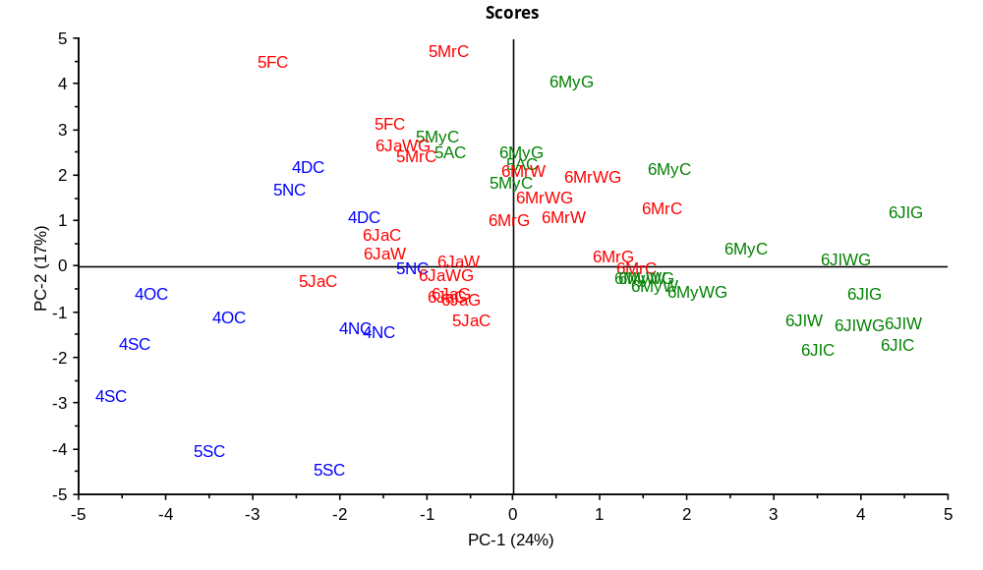

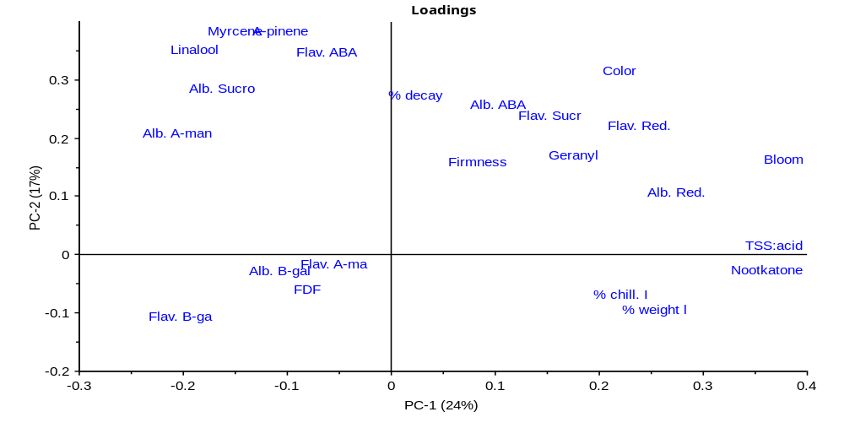
Figure 1. Scores (top) and loadings (bottom) plots of principal component analysis of ‘Marsh’ grapefruit harvested over 2 seasons and stored for 12 weeks at 40^{O}F using 22 physical and chemical characteristics and time from bloom date with indication of harvest time and treatments in the PC-1/PC-2 (n = 54). (Blue) = early season, (red) = mid-season, (green) = late season, 4 = 2004, 5 = 2005, 6 = 2006, S = Sept., O = Oct., N = Nov., D = Dec., Ja = Jan., F = Feb, Mr = Mar., A = Apr., My = May, Jl = Jul., C = control, W = water stress, G = growth regulators, WG = water stress × growth regulators, TSS: acid = juice TSS: acid ratio, % Weight L= fruit weight loss, % Decay = decayed fruits, % Chill. I = chilling injured fruits, FDF = fruit detachment force, Firmness = peel puncture resistance, Color = peel color, Flav. = flavedo, Alb. = albedo, Sucr/Sucro = sucrose, Red = reducing sugars, A-ma = α-mannosidase, B-gal = β-galactosidase, ABA = abscisic acid, Nootkatone, Geranyl acetate, Linalool, A-pinene, Myrcene = volatile components, and fruit age calculated from full bloom to harvest time (Bloom). PCs total variance = 41%.
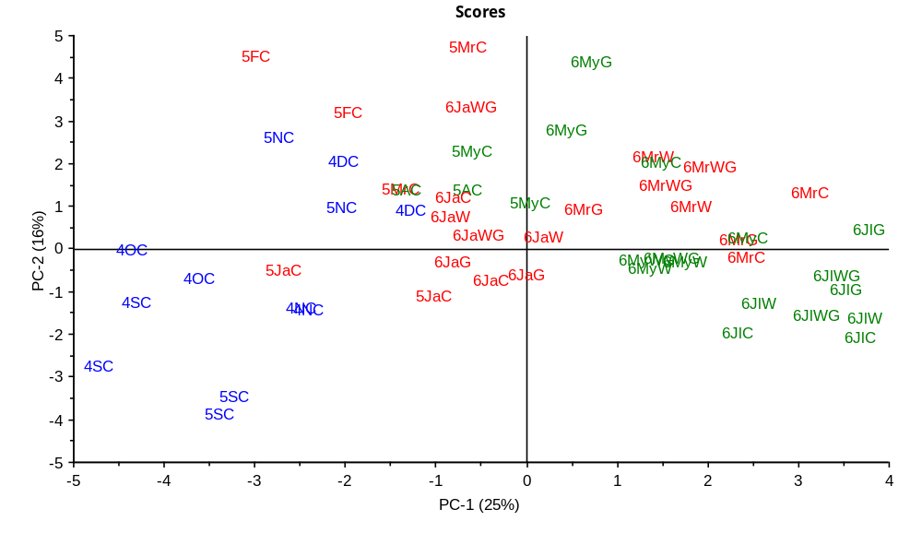

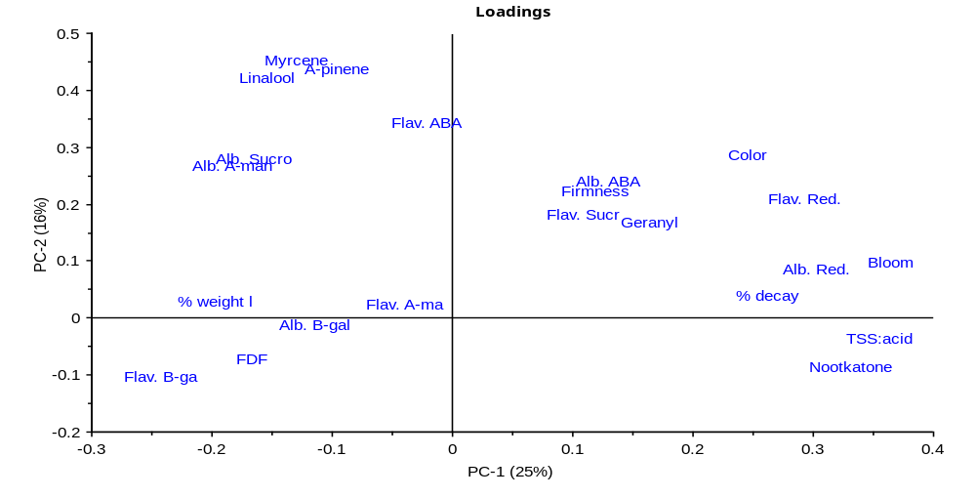
Figure 2. Scores (top) and loadings (bottom) plots of principal component analysis of ‘Marsh’ grapefruit harvested over 2 seasons and stored for 12 weeks at 70^{O}F using 21 physical and chemical characteristics and time from bloom date with indication of harvest time and treatments in the PC-1/PC-2 (n = 54). (Blue) = early season, (red) = mid-season, (green) = late season, 4 = 2004, 5 = 2005, 6 = 2006, S = Sept., O = Oct., N = Nov., D = Dec., Ja = Jan., F = Feb, Mr = Mar., A = Apr., My = May, Jl = Jul., C = control, W = water stress, G = growth regulators, WG = water stress × growth regulators, TSS: acid = juice TSS: acid ratio, % Weight L= fruit weight loss, % Decay = decayed fruits, FDF = fruit detachment force, Firmness = peel puncture resistance, Color = peel color, Flav. = flavedo, Alb. = albedo, Sucr/Sucro = sucrose, Red = reducing sugars, A-ma = α-mannosidase, B-gal = β-galactosidase, ABA = abscisic acid, Nootkatone, Geranyl acetate, Linalool, A-pinene, Myrcene = volatile components, and fruit age calculated from full bloom to harvest time (Bloom). PCs total variance = 41%.
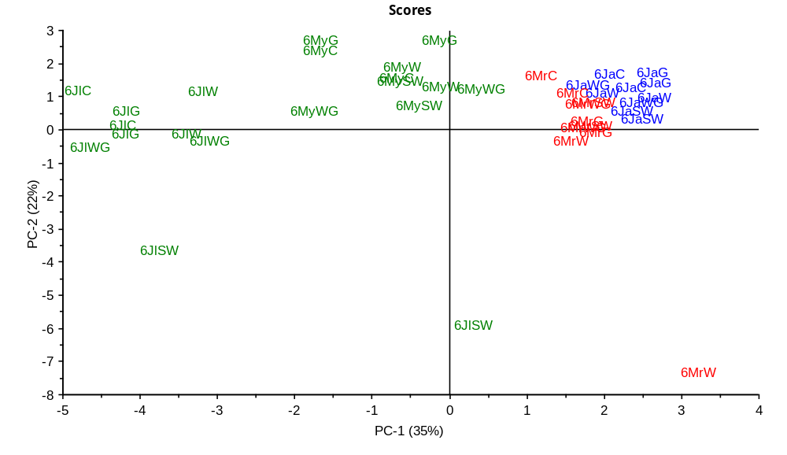
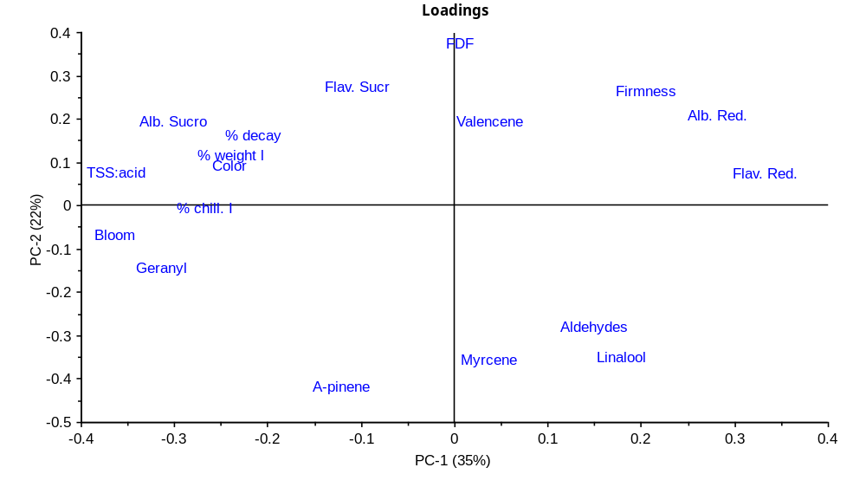
Figure 3. Scores (top) and loadings (bottom) plots of principal component analysis of ‘Valencia’ orange harvested in 2005/2006 season and stored for 12 weeks at 40^{O}F using 17 physical and chemical characteristics and time from bloom date with indication of harvest time and treatments in the PC-1/PC-2 (n = 40). (Blue) = early season, (red) = mid-season, (green) = late season, 6 = 2006, Ja = Jan., Mr = Mar., My = May, Jl = Jul., C = control, W = water stress, G = growth regulators, WG = water stress × growth regulators, TSS: acid = juice TSS: acid ratio, % Weight L= fruit weight loss, % Decay = decayed fruits, % Chill. I = chilling injured fruits, FDF = fruit detachment force, Firmness = peel puncture resistance, Color = peel color, Flav. = flavedo, Alb. = albedo, Sucr/Sucro = sucrose, Red = reducing sugars, Aldehydes, Geranyl acetate, Linalool, A-pinene, Myrcene, Valencene = volatile components, and fruit age calculated from full bloom to harvest time (Bloom). PCs total variance = 57%.
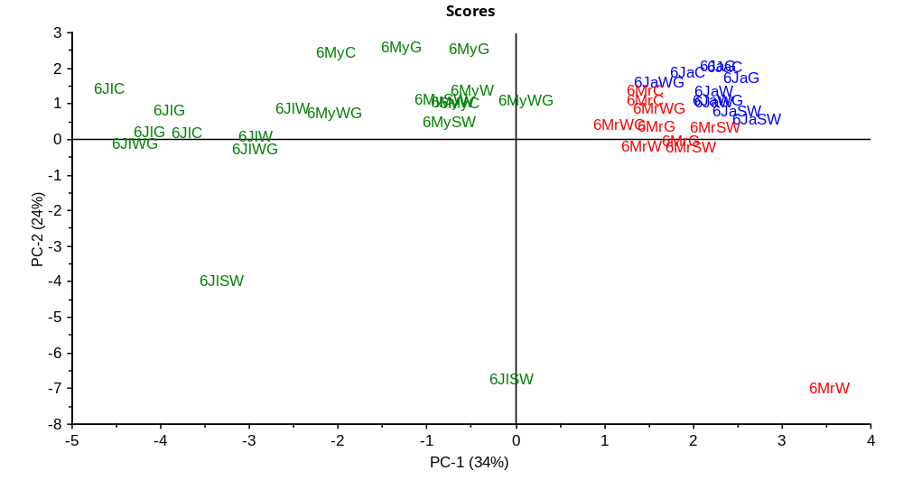

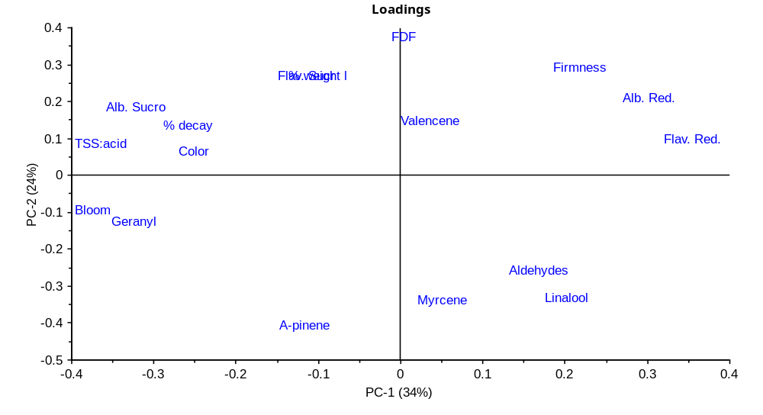
Figure 4. Scores (top) and loadings (bottom) plots of principal component analysis of ‘Valencia’ orange harvested in 2005/2006 season and stored for 12 weeks at 70^{O}F using 16 physical and chemical characteristics and time from bloom date with indication of harvest time and treatments in the PC-1/PC-2 (n = 40). (Blue) = early season, (red) = mid-season, (green) = late season, 6 = 2006, Ja = Jan., Mr = Mar., My = May, Jl = Jul., C = control, W = water stress, G = growth regulators, WG = water stress × growth regulators, TSS: acid = juice TSS: acid ratio, % Weight L= fruit weight loss, % Decay = decayed fruits, FDF = fruit detachment force, Firmness = peel puncture resistance, Color = peel color, Flav. = flavedo, Alb. = albedo, Sucr/Sucro = sucrose, Red = reducing sugars, Aldehydes, Geranyl acetate, Linalool, A-pinene, Myrcene, Valencene = volatile components, and fruit age calculated from full bloom to harvest time (Bloom). PCs total variance = 58%.

